# **Submariner Date**

Oyster, 41mm, Oystersteel Reference 126610LV

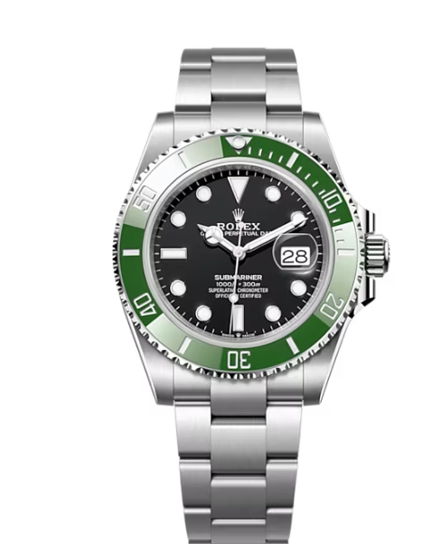

Deep confidence

## The Oyster Perpetual Submariner Date in Oystersteel with a Cerachrom bezel insert in green ceramic and a black dial with large luminescent hour markers.

## **Unidirectional Rotatable Bezel**

### **An underwater tool**

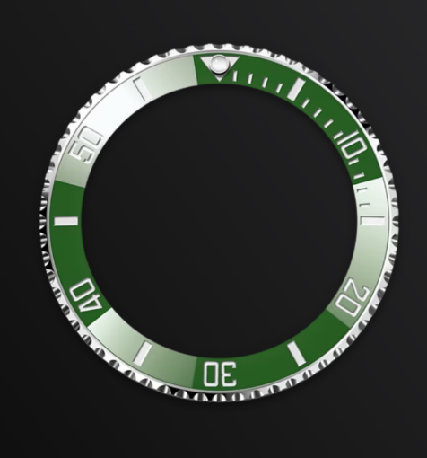The Submariner's rotatable bezel is a key functionality of the watch. Its 60-minute graduations allow a diver to accurately and safely monitor diving time and decompression stops.

Manufactured by Rolex from a hard, corrosion-resistant ceramic, the Cerachrom bezel insert is virtually scratchproof. A luminescent capsule on the zero marker ensures legibility, no matter how dark the environment. The bezel’s knurled edge is carefully designed to offer excellent grip under water, even with gloves.

## **Black dial**

### **For legibility underwater**

The dial’s luminescent Chromalight display is an innovation that improved visibility in dark environments, an essential feature for divers.

Hour markers in simple shapes – triangles, circles, rectangles – and broad hour and minute hands enable instant and reliable reading to prevent any risk of confusion underwater.

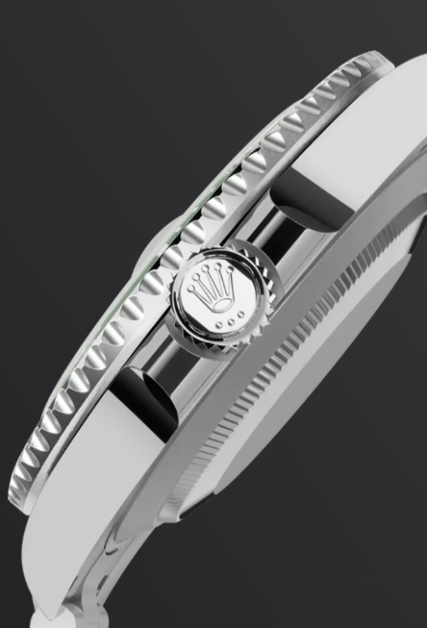

## 

## **Oystersteel**

### **Highly resistant to corrosion**

Rolex uses Oystersteel for its steel watch cases. Specially developed by the brand, Oystersteel belongs to the 904L steel family, alloys most commonly used in high-technology and in the aerospace and chemical industries, where maximum resistance to corrosion is essential.

Oystersteel is extremely resistant, offers an exceptional finish once polished and maintains its beauty even in the harshest environments.

## **The Oyster bracelet**

### **Alchemy of form and function**

The Oyster bracelet is a perfect alchemy of form and function, aesthetics and technology, designed to be both robust and comfortable.

It is equipped with an Oysterlock clasp, which prevents accidental opening, and an ingenious Glidelock, allowing fine adjustments of the bracelet without using any tools — and allowing it to be worn comfortably over a diving suit.